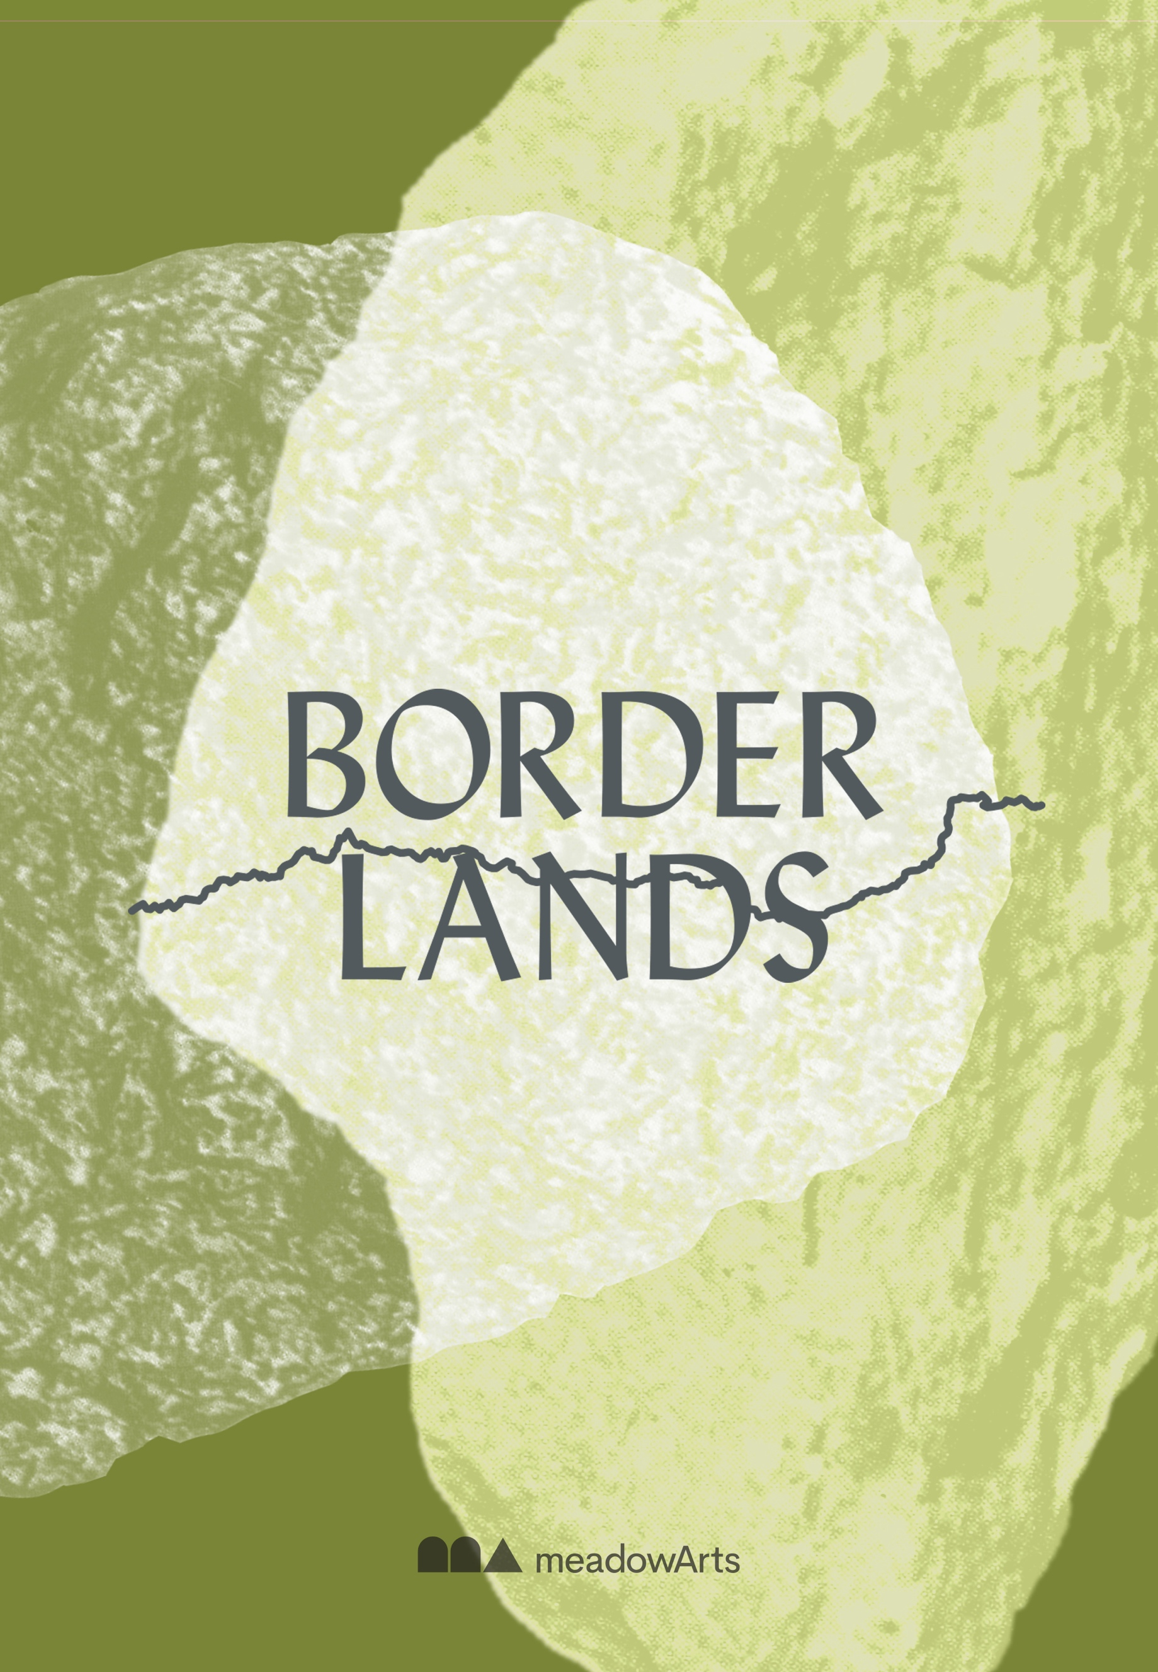

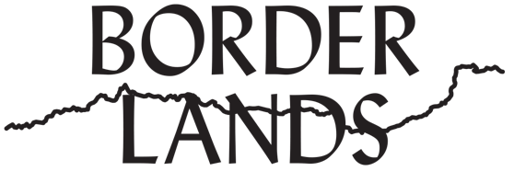

Visual Artist Commission Brief - Borderlands Year 1

Location: Herefordshire-Powys border region (Hay on Wye, Kington, Knighton)
Timeline: May 2025 – early 2026 (exact schedule to be developed with the artist)
Engagement: The artist will work with communities through participatory activities.
Final Outcome: A new artwork, shaped by contact with communities and presented as a performance. The work will emerge through participation, unfolding as an experience shared with those involved in the project. It will be documented on film and shared locally and online, then exhibited in a high-profile cultural venue from April – June 2026.

Introduction
In this first year of our Borderlands project, Meadow Arts is seeking an artist to develop a new commission in collaboration with communities situated in the Welsh Borders region. This participatory commission invites an artist to explore themes of borders, regions, and identity, responding to the landscape, histories, and communities of the area.

We are particularly interested in visual artists working with performance-based approaches and those experienced in collaborative, community-led practice. The commissioned artist will spend time in the region, engaging with local people to co-create a performance-based work, performed and experienced directly by those taking part.

About Meadow Arts
Meadow Arts is an inspirational contemporary visual arts charity delivering ambitious and accessible projects in unexpected, often rural places. Born in a meadow in 2001, Meadow Arts has evolved to become an important part of the creative landscape across Herefordshire, Shropshire and Worcestershire, collaborating with a variety of significant partners and host locations.
meadowarts.org

About Borderlands
Borderlands is a three-year, place-based partnership project inspired by the historic Offa’s Dyke and the region known as the Welsh Border. This project asks how borders, rather than dividing territory and communities, can become points of connection and shared identity. Through contemporary visual art, we want to explore how communities experience and interpret the concept of borders in their own lives as well as on a global scale.

In Year 1, the selected artist will work in the border region (concentrating on Hay on Wye, Kington, Knighton) through participatory workshops, conversations, and creative activities. The final artistic outcome will take the form of a performance shaped by collective involvement and experienced directly by those taking part. This shared act of imagination and participation will be documented and presented digitally and in community venues. It will then be presented at a high-profile cultural venue in the region as part of an exhibition from April - June 2026 during an international arts and literature festival.

We are looking for a visual artist who:
- Works with performance, participatory rituals, traditions, or other forms of live art.
- Has experience with place-based, collaborative and participatory practices.
- Can creatively respond to landscape, heritage, and community traditions while helping to create something new together.
- Is open to engaging deeply with local people through conversations, storytelling, and shared experiences.
- Can develop an artistic outcome that will be exhibited and publicly shared in exhibition settings and digitally.
- Has access to their own transport and is comfortable working in a rural location.
- Can visit the area for a few days at a time over the course of the project.
- The artist may be required to undergo a DBS check

Working with Communities
Facilitated by Meadow Arts, the artist will spend time in the Herefordshire-Powys border region, developing an artwork in direct collaboration with communities. We anticipate a series of short visits, with the schedule developed in partnership with the artist.

This commission is rooted in participation, inviting people into a creative process that fosters inclusion and belonging. The focus is on shared experiences rather than passive observation. The artist may work with specific groups - such as local heritage organisations, schools, or community centres - or engage more broadly through open workshops and activities. Meadow Arts will support connections with local partners while allowing the artist to develop their own relationships and methods of engagement.

A note on language and landscape
Borderlands explores the meaning of borders - both physical and conceptual - with communities living near them. The region’s striking landscape is central to the project, and we welcome artistic approaches that engage with the outdoor environment. Language may also be a key theme, shaping identity, belonging, and cross-border communication.

Evaluation & Documentation
As part of the commission, the artist will be invited to document aspects of their process, whether through writing, photography, video, or other means. The artist may also be asked to contribute to the evaluation of Borderlands, including reflecting on the impact of the work and sharing learning with Meadow Arts and project partners.

Final Outcome
The commissioned artwork will remain the intellectual property of the artist. However, Meadow Arts and project partners will have the right to document, share, and present the work publicly in relation to Borderlands. We will work with the artist to ensure appropriate agreements are in place for ongoing use, archiving, and digital accessibility.

Commission Timeline
April 2025: Open Call for artists launched
May 2025: Artist selected, contract signed, and orientation begins
June – mid-September 2025: Artist residency (remote and in-person as needed)
September 2025: Development and presentation of final outcome/performance
October 2025: January 2026 – Post-production phase
January 2026: Completion of final artistic outcome
February – March 2026: Digital and local presentations of the final work

Budget (indicative)
We have a total budget of £12,000 (inclusive of VAT), allocated as follows:

Artist Fees: £4,000
Artist Expenses: £1,000
*Production: £5,000
Participatory Activities: £2,000

*The production budget (£5,000) is intended to cover materials, equipment, and any technical support required to realise the final artistic outcome.

Accessibility
Meadow Arts is committed to ensuring that this commission is accessible to artists from all backgrounds. We encourage applications from those who may face barriers to participation, including disabled artists, artists from underrepresented communities, and those with caring responsibilities. We will work with the selected artist to discuss and accommodate any access requirements, including:

- Flexible working arrangements.
- Support with travel and accommodation where required.
- Accessibility considerations for participatory workshops and public engagement.

Selection Process
Applications will be reviewed by a panel that includes representatives from Meadow Arts, project partners, and community members where possible. Selection will be based on:

- Artistic quality and relevance to the themes of Borderlands
- Experience and approach to participatory practice
- Ability to respond to place and community engagement
- Feasibility of the proposed approach within the available budget and timeline (applicants are encouraged to provide an outline budget detailing how their fee and expenses may be allocated)

Shortlisted artists may be invited to have an informal conversation before the final selection is made.

How to Apply
If you are interested in this opportunity, please submit:

- A short statement (max 500 words) on why you are interested and how your practice aligns with the project.
- An indication of how you may approach this commission (including an outline budget detailing how your fee and expenses will be allocated.)
- Up to 3 examples of past work, with a focus on participatory and site-specific projects.
- A CV or bio outlining relevant experience.

We welcome applications in written, audio, or video formats, sent to rose@meadowarts.org.

Deadline for applications: 5pm on 27th April 2025

To discuss the opportunity, contact Anne de Charmant at anne@meadowarts.org.

